Exercise 5

Time Series Data Analysis

Colab link

https://colab.research.google.com/drive/18fIgoDyclXyNYNFzoMvnszPKelntU-dy?usp=sharing

AIM:

To perform time series analysis by applying various visualization techniques.

Data Description:

This dataset contains several columns like date, symbol, series, previous close, open, high, low, last, close, vwap, volume and turnover of tatasteel company.

import pandas as pd

import numpy as np

import matplotlib.pyplot as plt

import pandas as pd

df=pd.read_csv('/content/tatasteel mod.csv')

df.head()

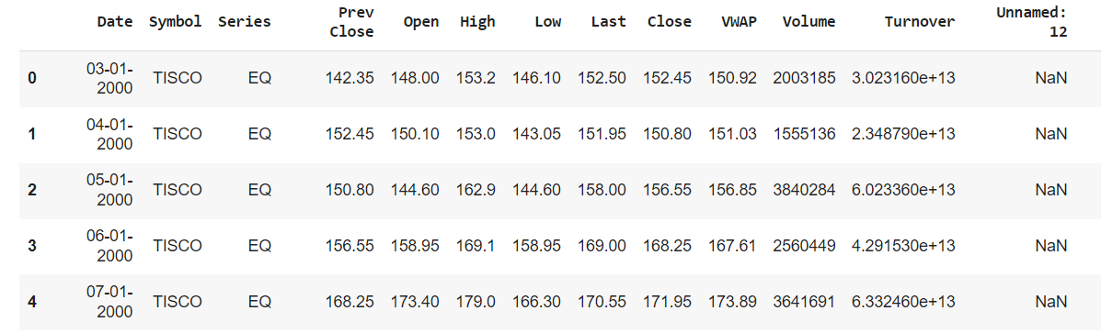

df.drop(columns='Unnamed: 12')

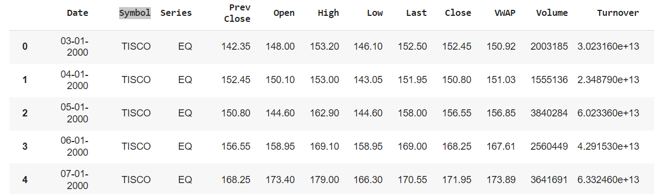

df['Prev Close'].plot()

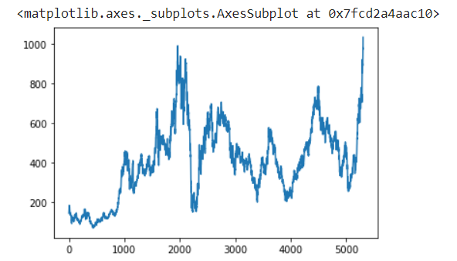

df['Open'].plot()

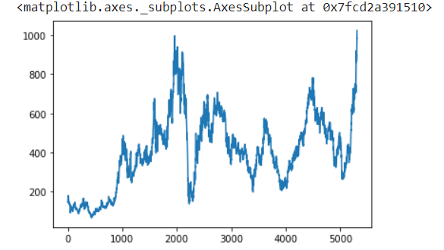

df['Close'].plot()

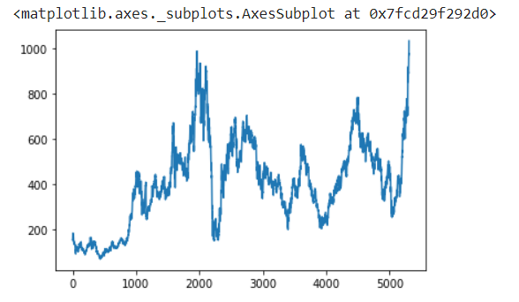

*OBSERVATION: There is no big change in share values in open, close and previous day value.*

df.plot(subplots=True, figsize=(10, 12))

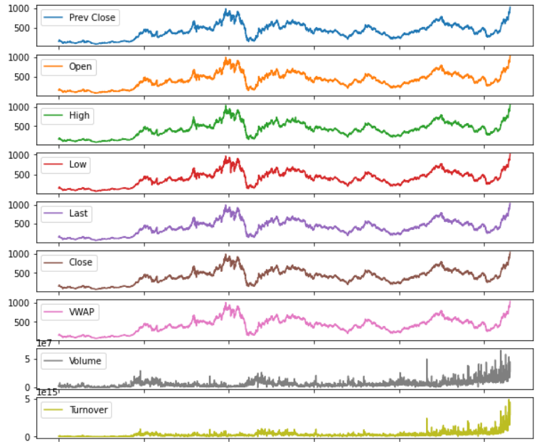

*OBSERVATION: This gives us the graph of every columns.*

df['Change'] = df.Close.div(df.Close.shift())

df['Change'].plot(figsize=(10, 8), fontsize=16)

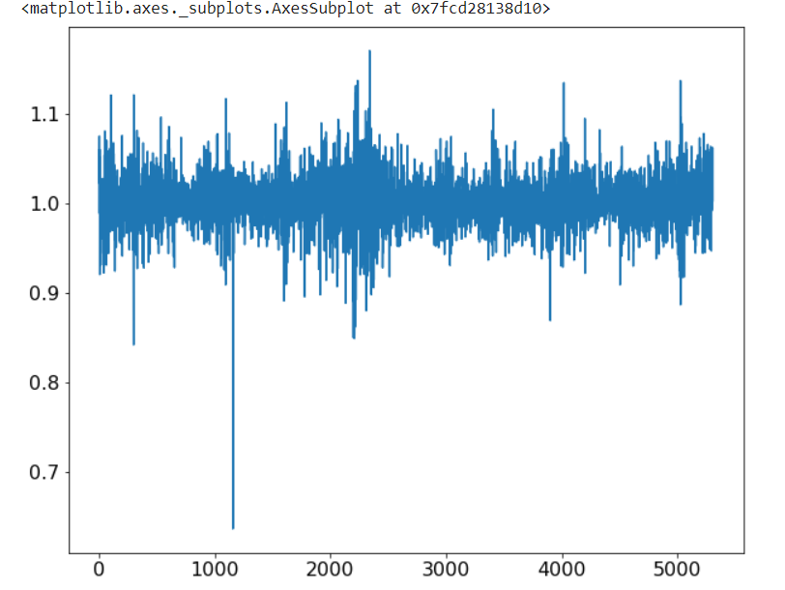

*OBSETVATION: This is the overall change in the dataset*

#line plot

from pandas import read_csv

from matplotlib import pyplot

series = read_csv('/content/tatasteel mod.csv', header=0, index_col=0, parse_dates=True, squeeze=True)

series.plot(style='k.')

pyplot.show()

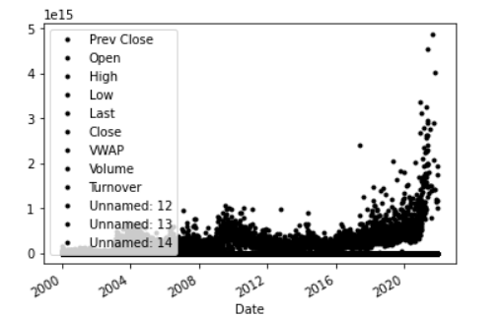

*OBSERVATION: Scatterplot for the dataset.*

#Time Series Histogram and Density Plots

from pandas import read_csv

from matplotlib import pyplot

series = read_csv('/content/tatasteel mod.csv', header=0, index_col=0, parse_dates=True, squeeze=True)

series.hist()

pyplot.show()

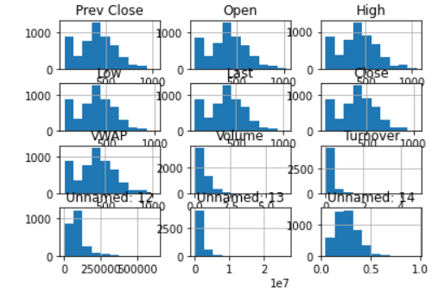

*OBSERVATION: Bar graph for every columns in dataset.*

#kde plot

from matplotlib import pyplot

series = read_csv('/content/tatasteel mod.csv', header=0, index_col=0, parse_dates=True, squeeze=True)

series.plot(kind='kde')

pyplot.show()

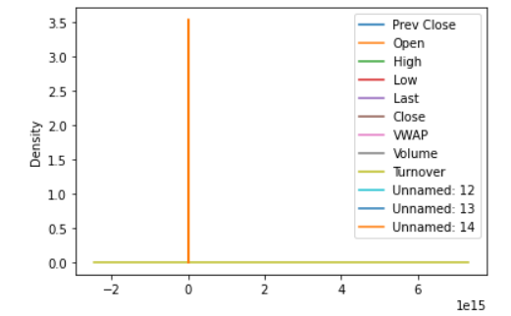

*OBSERVATION: Only opening values are considerable.*

import seaborn as sns

import matplotlib.pyplot as plt

sns.lineplot(x='VWAP',y='Turnover',data=df,hue='Symbol')

plt.show()

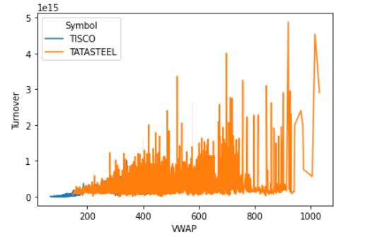

OBSERVATION: Tatasteel symbol has more value than TISCO.

sns.barplot(x='Open',y='Turnover',data=df,hue='Symbol')

plt.show()

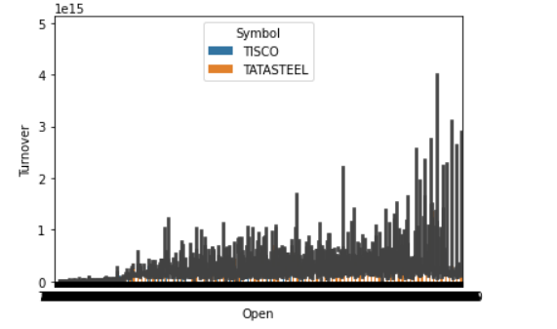

*OBSERVATION: Turnover for tatasteel is greater than TISCO.*

sns.scatterplot(x='Open',y='Close',data=df,hue='Symbol')

plt.show()

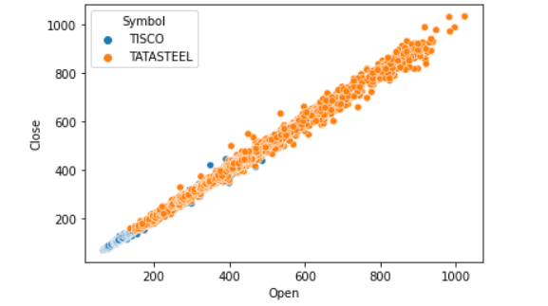

*OBSERVATION: Stock values of tatasteel is more than TISCO.*

sns.distplot(df['Prev Close'])

plt.show()

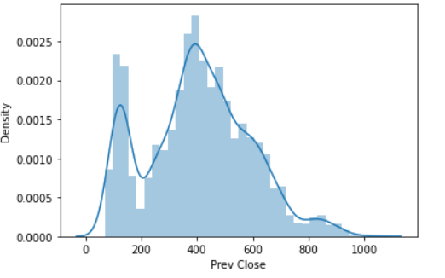

*OBSERVATION: Previous day’s closing values are given in this distplot.*

sns.jointplot(x='High',y='Low',data=df)

plt.show()

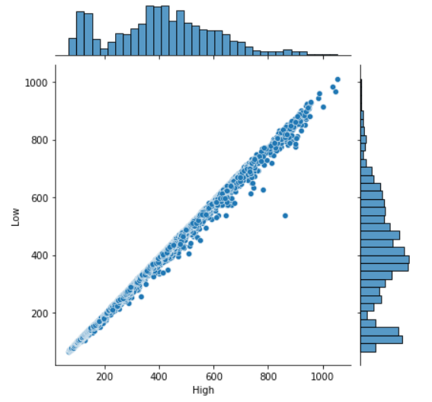

OBSERVATION: Higher and lower values of Tatasteel.

sns.jointplot(x='Volume',y='Last',data=df,kind='reg')

plt.show()

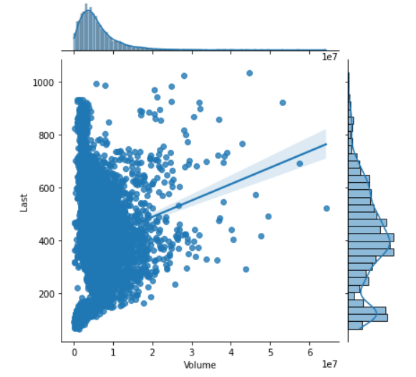

*OBSERVATION: Linear regression for Volume of tatasteel*.

sns.pairplot(df,hue='Symbol')

plt.show()

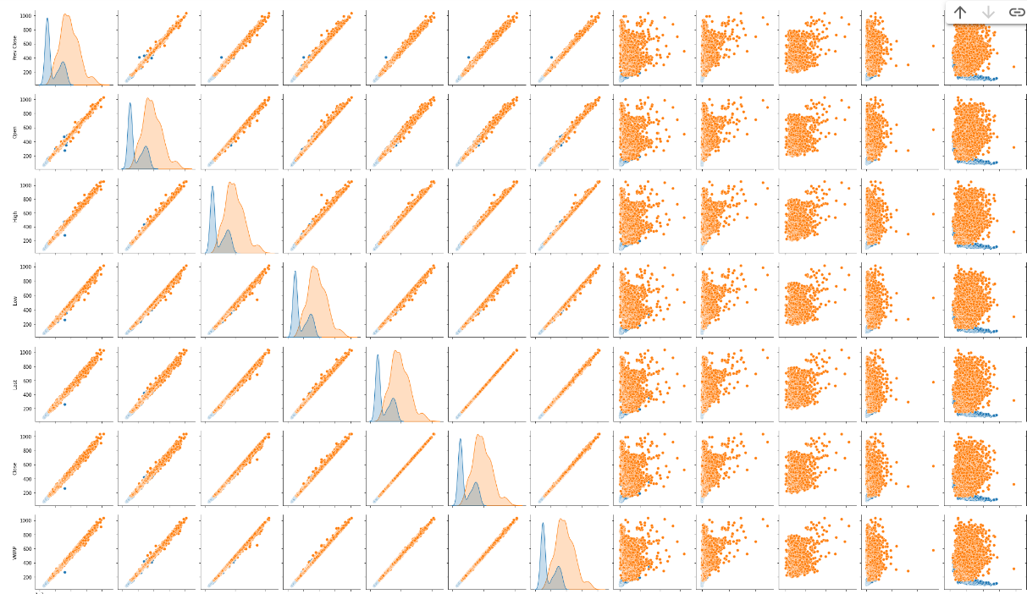

*OBSERVATION: Overall representation of dataset.*

*Result:* Thus time series analysis by applying various visualization techniques were successfully executed.